Student Name: Calvin Moylan

Student ID: 30018702

Date: 11/09/2020

Assessment Title: Portfolio One

## AT 2: Activity 4

## Design Specifications

This application, is a client and server login system. The program requires that a client must login to the server with a username and password. The password must be checked against the server’s database of usernames and hashed passwords. If the user and pass is correct, the user is let into the server.

## Design Specifications Analysis

For this task, I have followed all requirements, which includes a client and server program and server side password hashing. The two applications can communicate with each other over sockets. The admin client also has its own username and login details that must be entered before the server starts. The admin can also add more users to the database that the client can then use to login with.

## Debugging

Checking the user details:  
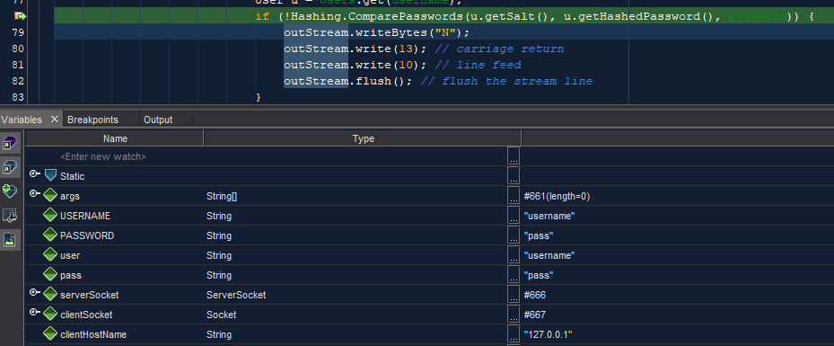  
Testing Admin details:  
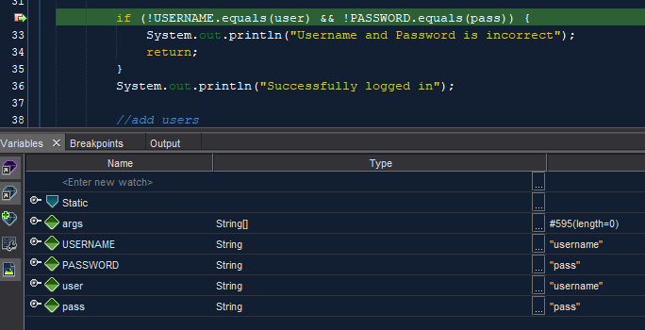

Adding new user:  
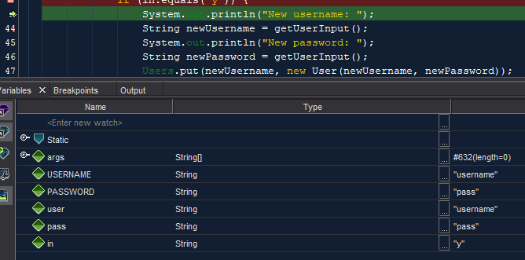

## Testing the Application

### Test and validate with sample inputs with screenshots.

|  |  |  |  |  |
| --- | --- | --- | --- | --- |
| **#** | **Test Case** | **Data** | **Expected Result** | **Actual Result / Comment** |
| *Case 1* | *Logging into the server* | *User input of admin username and password which are correct* | *Admin is logged in* | *Results as expected.*  *Ref Figure 1.1* |
| *Case 2* | *Logging into the server with incorrect details* | *User input of admin username and password which are incorrect* | *Admin is not logged in* | *Results as expected.*  *Ref Figure 1.2* |
| *Case 3* | *Admin creating more users* | *User inputting new usernames and passwords* | *Users are added.* | *Results as expected.*  *Ref Figure 1.3* |
| *Case 4* | *Client joining the server with correct details* | *Client inputting correct username and password details into server.* | *Client joins server* | *Results as expected.*  *Ref Figure 1.4* |
| *Case 5* | *Client joining the server with incorrect details* | *Client inputting incorrect username and password details into server.* | *Client does not join the server* | *Results as expected.*  *Ref Figure 1.5* |
| *Case 6* | *Sending message to the server* | *Client chat input* | *Message is received and sent back to the client* | *Results as expected.*  *Ref Figure 1.6* |

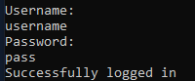

Figure 1.

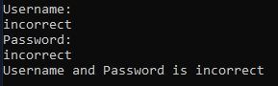

Figure 1.2

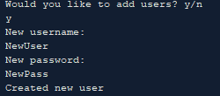

Figure 1.3

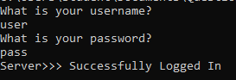

Figure 1.4

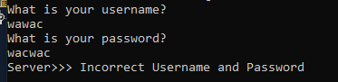

Figure 1.5

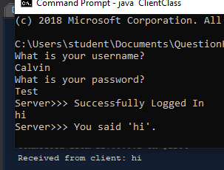

Figure 1.6

END OF TEST TABLE

## Implementation

The application has been uploaded to GitHub under the url: <https://github.com/CalvinMoylanTAFE/JavaThreePortfolio/tree/main/QuestionFour>  
Here we will be able to update the repository if any future changes are necessary such as a bug fix or a future feature. The application can be implemented on any computer that supports Java Runtime Environment so deploying the application will require JavaRE to be installed.